Logic Design Final Exam (SW)
2022. 05. 30.
10 points/problem if not specified.

1. Simplify the expression.
(A + BC’ + D’E) (A + D’E)

2. For F’(A, B, C, D) = Σ m(1, 2, 5, 6, 10, 15)
(a) Find the minterm expression using K-map.
(b) Modify your expression to prevent any hazard(s)

3. Find a minimum SOP solution using the QM method.
f(a, b, c, d) = Σ m(1, 3, 4, 5, 6, 7, 10, 12, 13) + Σ d(2, 9, 15)

4. Convert the following circuit to all NAND gates.
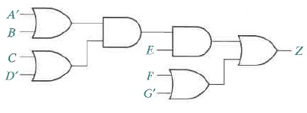
5. Design an 8-to-1 MUX with 2-to-1 MUX(s) and 4-to-1 MUX(s).
Specify three control (select) lines.

6. Derive the characteristic and excitation equations for SR, JK, and T type
flip-flops.

7. Design a dozen counter (0~11) with JK type flip-flops. (20 points)

8. Design a Moore type sequence detector for finding ‘010” with T type flip-flops. (20 points)

